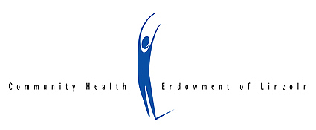

**FOR IMMEDIATE RELEASE Contact:** Lori Vrtiska Seibel, President/CEO

October 8, 2019 402-436-5516, [lori.seibel@chelincoln.org](mailto:lori.seibel@chelincoln.org)

# **Place Matters 3.0 Maps Show Health Changes, Challenges**

(LINCOLN, Nebraska) The Community Health Endowment of Lincoln (CHE) and the Lincoln-Lancaster County Health Department (LLCHD) today released Place Matters 3.0, the third edition of a community mapping project that visually displays data related to health factors and outcomes in Lincoln. Previous versions were released in 2015 and 2017.

“Place Matters 3.0 shows some exciting improvements,” said Lori Seibel, CHE President/CEO. “Eight census tracts now meet Lincoln’s goal that 90% of pregnant women receive care in the first trimester up from zero in 2017, and access to healthy food is improving in targeted areas of our community. However, Lincoln still faces challenges,” noted Seibel. “For the first time since 2010, Lincoln has a census tract where more than 50% of the residents live in poverty.”

New this year are maps showing rates of health insurance coverage, adult visits to a doctor for a routine check-up, and youth fitness. The project previously mapped childhood obesity, but research increasingly indicates that cardiorespiratory fitness is a more powerful predictor of illness or mortality than obesity and correlates more strongly with academic performance. Place Matters 3.0 shows that 19 of Lincoln’s 74 census tracts meet the goal that 80% of LPS students pass the Fitnessgram PACER test.

Mayor Leirion Gaylor Baird cited the maps as a guidepost for action, “Place Matters calls on each of us to do our part to improve outcomes for every resident,” said Gaylor Baird. “Thank you to the Community Health Endowment and the Lincoln-Lancaster County Health Department for continuing to lift up the importance of equity in our community and for inspiring us to do even more.”

In addition to CHE and LLCHD, organizations contributing to Place Matters 3.0 include the Lancaster County Medical Society, Lincoln Public Schools, the City of Lincoln Urban Development Department, Nebraska Extension, Partnership for a Healthy Lincoln and the Division of Public Health of the Nebraska Department of Health and Human Services.

# # #

*CHE is a municipal endowment dedicated to making Lincoln the healthiest community in the nation. To achieve this vision, CHE invests in health-related projects and programs and convenes the community around important health issues. Since its inception in 1998, CHE has returned more than $31 million to the community.*